
GDPR & Data Protection Policy

- Privacy Policy
- Data Protection & Security Policy
- Data Protection Impact Assessment
- Data Sharing
- Data Breach
- Subject Access Requests (Sar)

Privacy Policy
The GDPR is Europe's new framework for data protection laws. It replaces the previous 1995 data protection directive, which current UK law is based upon. The new regulation starts on 25 May 2018. It will be enforced by the Information Commissioner's Office (ICO).
Central Employment is committed to protecting and respecting your privacy. This notice sets out the basis on which any personal data we collect from you, or that you provide us, will be processed by us.

The name and contact details of our organisation
Central Employment (North East) Limited will be what is known as the 'Controller' of the personal data you provide to us. Central Employment registration number is 2115676 and our registered address is Portland House, Ground floor blocks A & B, 54 New Bridge Street West, Newcastle upon Tyne, Tyne and Wear, NE1 8AP.

The name and contact details of our representative & data protection officer
Louise Denyer will be what is known as the 'Data Protection Officer' of the personal data you provide to us. Louise can be contacted at Central Employment on 0191 2324816 or by email at enquires@centralemployment.co.uk

The purposes of the processing
We are a recruitment agency and recruitment business as defined in the Employment Agencies and Employment Business Regulations 2013. We collect personal data on individuals to allow us to operate our business for the following general purposes:
- Staff administration
- Advertising, marketing & public relations
- Accounts & records
- Administration and processing of work-seekers personal data for the purposes of work-finding services

The lawful basis for the processing
There are several lawful reasons we may process your personal data under the GDPR. These include:
- The individual has given their consent to the processing of their data for a particular purpose;
- Processing is necessary in relation to a contract to which the individual has entered into or because the individual has asked for something to be done so they can enter into a contract;
- Processing is necessary because of a legal obligation that applies to the data controller (expect an obligation imposed by the contract);
- Processing in necessary for the purposes of the legitimate interests pursued by the controller or by a third party, except where such interests are overridden by the interests or fundamental rights and freedoms of the data subject.

The legitimate interests for the processing
Central Employment provide work finding services to both candidates and clients as part of our business. We process personal data in order to be able to provide these services – we need to check identity of candidates, their right to work and qualifications as well as process pay and manage entitlement to certain statutory rights. It is in the legitimate interests of all parties involved – Central Employment, the work seeker and the client – that Central Employment can process this data.
There are three main criteria that we will meet when using legitimate reasons to process your personal data under the GDPR. These are:
- Central Employment need to process the information for our own legitimate interest or for those of a third party to whom we may disclose the data
- Our legitimate interests are balanced against the individuals interests. Where there is a serious mismatch between competing interests, the individual’s legitimate interest will take priority; and
- Any processing under the legitimate interest condition will be fair and lawful and compliant with all data protection principles.

The categories of personal data obtained
In order to provide the best possible employment opportunities that are tailored to our candidates, we need to obtain and store certain information. We only ask for details that will genuinely help us to help candidates find a new role and to remain legally compliant.
- Contact details
- Pay details
- Qualifications
- Employment history
- Ethnicity
- Disability details
- Medical details
- References
- Driving Licence details
- RTW eligibility
- Client specific paperwork
- Interview notes
- Oher relevant information you may choose to share.
Certain data is classified as ‘sensitive personal data’ where appropriate, and in accordance with local laws and requirements. This will include data about;
- Your racial or ethnic origin
- Your political opinions
- Your religious beliefs or other beliefs of a similar nature
- Your membership or non-membership of a Trade Union
- Your physical or mental health condition
- Your sex life
- Any commission or alleged commission of any offence, or any proceedings for any offence committed or alleged to have been committed by you, the disposal of such proceedings or the sentence of any court in such proceedings.
We need you to provide your consent to us processing your sensitive personal data during your engagement with us. We will ask you to sign a Data Protection Consent From to confirm this.
If you are looking for employment or have posted your professional CV information on a publicly available data platform (e.g. job board or professional networking site), your publicly available personal data may be used to provide our recruitment services to you, share that information with prospective employers (with your consent) and assess your skills against our live vacancies. During the job offer process, your potential employer may also want to confirm your references, qualifications and criminal record, to the extent that this is appropriate and in accordance with the law. We need to request/hold this data so that we can help you and our clients with our recruitment services.
If you are a Central Employment existing client, we need to collect and use information about you, or individuals at your organisation, in the course of providing you with our recruitment services. This can include finding candidates to fill your roles. If you are a Central Employment potential client, we will source our information from you from publicly available sources.
We collect a limited amount of data from the users of our website which we use to help us to improve your experience when using our website and to help us manage the services we provide. This includes information such as how you use our website, the most popular referrers and website responsiveness. You can read more about this in our Cookies Policy.

The recipients or categories of recipients of the personal data
As required under GDPR, we will only share your information to prospective employers and with your express consent.
Unless you specify otherwise, we may also share your information with any of our group companies and associated third parties such as our service providers where we feel this will help us to provide you with the best possible service and we have the appropriate processing agreement in place.
We may also be required to disclose your personal data to the police or other enforcement, regulatory or Government body, in your country of origin or elsewhere, upon a valid request to do so. These requests are assessed on a case-by-case basis and take the privacy of our customers into consideration.

The details of transfers of the personal data to any third countries or international organisations
Providing Information to Third Parties
In some cases, we are required by law to pass your data on to a third party. This will apply to instances such as setting up a workplace pension scheme. If there are no grounds in data protection law for us to pass your personal data on to a third party, we must obtain your consent before passing on your details. We will contact you to obtain your consent if this is necessary.

The retention periods for the personal data
Under new data protection regulations (GDPR), we are required to keep the data we hold accurate and, where necessary, up to date. As such, we will make an effort to regularly communicate with you to ensure your data is up to date and accurate.
We will delete candidate personal data from our systems if we have not had any meaningful contact with you for two years (or for such longer period as we believe, in good faith, that the law or relevant regulators require us to preserve your data). After this period, whenever we collect or process your personal data, we’ll only keep it for as long as is necessary for the purpose of which it was collected for.

2 years post-campaign – Personal data
3 years post-employment – Bank Details
5 years post-employment – Contact Details
6 years post-employment – Tax Details
75 years post-employment – Pension Details

We will consider there to be meaningful contact with you if you submit your updated CV onto our website, apply for jobs with us or we receive an updated CV from a job board. We will also consider it meaningful contact if you communicate with us about potential roles, either by verbal or written communication.

Whilst we will endeavour to permanently erase your personal data once it reaches the end of its retention period or where we receive a valid request from you to do so, some of your data may still exist within an archive system. While certain details may still exist on an archive system, this cannot be readily accessed by any of our operational systems, processes or staff.

The rights available to individuals in respect of the processing
As your employer/contractor, we need to hold your personal data to enable us to operate your contract of employment/contract for services. In holding your personal data, we will comply with the eight data protection principles which require that your data must be;
- Processed fairly and lawfully.
- Processed for limited purposes and in an appropriate way.
- Adequate, relevant and not excessive for the purpose.
- Accurate.
- Not kept longer than necessary for the purpose.
- Processed in line with individuals' rights.
- Secure.
- Not transferred to people or organisations situated in countries without adequate protection.

Your Rights
You have the right to:
- Request access to any personal data we hold about you.
- Prevent the processing of your data for direct-marketing purposes.
- Ask to have inaccurate data held about you amended.
- Prevent processing that is likely to cause unwarranted substantial damage or distress to you or anyone else.
- Object to any decision that significantly affects you being taken solely by a computer or other automated process.

The right to withdraw consent
If you have given consent to the processing of your personal data you can withdraw your consent. When you withdraw your consent to processing, that withdrawal applies only to personal data collected by your consent. You may ask us to confirm what information we hold about you at any time, and request us to modify, update or delete such information. If you wish to access your data at any time by making a ‘subject access request’ (SAR) to our Data Protection Officer. The request should be fulfilled within 30 days.

The right to lodge a complaint with a supervisory authority
If you feel that your data has not been handled correctly, or you are unhappy with our response to any requests you have made to us regarding the use of your personal data, you have the right to lodge a complaint with the Information Commissioner’s Office.
You can contact them by calling 0303 123 1113.
Or go online to www.ico.org.uk/concerns (opens in a new window; please note we can't be responsible for the content of external websites)

If you are based outside the UK, you have the right to lodge your complaint with the relevant data protection regulator in your country of residence.

The source of the personal data
We may obtain candidate information from any number of locations:
- When you register with us in our office
- When you register with our website or apply for jobs via our website
- When you correspond with us by phone, email or otherwise
- When you register your CV on a job board and it matches the skills we're looking for
- When you apply for one of our jobs via a job board
- When you are referred by a friend / colleague
- Your personal profile (publicly available)

When we obtain your information from external sources such as LinkedIn, corporate websites and job boards we will inform you, by sending you this privacy notice, within a maximum of 30 days of collecting the data of the fact we hold personal data about you, the source the personal data originates from, and for what purpose we intend to retain and or process your personal data.
There are two main ways in which we collect client data:
- Directly from you
- From third parties such as candidates, online job boards, LinkedIn and networking.

The details of whether individuals are under a statutory or contractual obligation to provide the personal data
During your employment with Central Employment you will be under a statutory or contractual obligation to provide some of your personal data. If you fail to provide any of the personal data we request for our legitimate business interests if may result in the termination of your employment and or we will be unable to provide you with our full recruitment service.

The details of the existence of automated decision-making, including profiling
Central Employment do not use any automated decision-making or profiling with the data we receive from you. All of the personal data we hold about you will is processed by our staff, and accessed by our secure internal HR recruitment software. We take all reasonable technical and organisational precautions to ensure that your personal data is processed securely, to prevent the misuse or loss, prevent unauthorised access to or alteration of your personal data.

Changes to our privacy notice
Any changes we make to our privacy notice in the future will be posted on this page and, where appropriate, notified to you by email. Please check back frequently to see any updates or changes to our privacy notice.

Other websites
This website contains links to other websites. Central Employment is not responsible for the privacy policies or practices of any third party.

Contact
Questions, comments or requests regarding this privacy notice are welcomed and should be addressed by email to enquiries@centralemployment.co.uk

Data Protection & Security Policy

The Data Protection Act 1998
The Company processes personal data in relation to its own staff, work-seekers, and individual client contacts - therefore it is a "data controller" for the purposes of the Data Protection Act 1998. The Company has notified the Information Commissioner's Office — the Company's data protection registration number is Z770600
The Company holds personal data on individuals for the following general purposes:
- Staff administration.
- Advertising, marketing, and public relations.
- Accounts and records.
- Administration and processing of work-seekers personal data for the purposes of work-finding services.
The Eight Principles of Data Protection
The Data Protection Act 1998 requires the Company as data controller to process data in accordance with the principles of data protection. These require that personal data shall be:

- Fairly and lawfully processed.
- Processed for limited purposes.
- Adequate, relevant, and not excessive.
- Accurate.
- Not kept longer than necessary.
- Processed in accordance with the data subjects' rights.
- Kept securely.
- Not transferred to countries outside the European Economic Area without adequate protection.
"Personal data" means data, which relates to a living individual who can be identified from the data or from the data together with other information, which is in the possession of, or is likely to come into possession of the Company.
"Processing" means obtaining, recording, or holding the data or carrying out any operation or set of operations on the data. It includes organizing, adapting and amending the data, retrieval, consultation and use of the data, disclosing and erasure or destruction of the data. It is difficult to envisage any activity involving data, which does not amount to processing. It applies to any processing that is carried out on computer including any type of computer however described, main frame, desktop, laptop, iPad, Blackberry O or other mobile device.
Personal data may only be processed with the consent of the person whose data is held. Therefore, if they have not consented to their personal details being passed to a third party this may constitute a breach of the Data Protection Act 1998. By instructing the Company to look for work and by providing us with personal data contained in a CV work-seekers will be giving their consent to processing their details for work-finding purposes. Caution should be exercised before forwarding the personal details of any individuals on whom personal data is held, to any third party such as past, current or prospective employers, suppliers, customers and clients, persons making an enquiry or complaint and any other third party.
Sensitive Personal Data
Personal data in respect of the following is "sensitive personal data" and any information held on any of these matters MUST NOT be passed on to any third party without the express written consent of the individual:
Any offence committed or alleged to be committed by them.
Proceedings in relation to any offence and any sentence passed.
Physical or mental health or condition.
- Racial or ethnic origins.
- Sexual life.
- Political opinions.
- Religious beliefs or beliefs of a similar nature.
- Whether someone is a member of a trade union.
Information Security
From a security point of view, only those staff authorised are permitted to add, amend, or delete personal data from the Company's database(s) ("database" includes paper records or records stored electronically). However, all staff are responsible for notifying those listed where information is known to be old, inaccurate, or out of date. In addition, all employees should ensure that adequate security measures are in place. For example:
- Computer screens should not be left open by individuals who have access to personal data.
- Passwords should not be disclosed.
- Email should be used with care.
- Personnel files and other personal data should be stored in a place in which any unauthorised attempts to access them will be noticed. They should not be removed from their usual place of storage without good reason.
- Personnel files should always be locked away when not in use and when in use should not be left unattended.
- Any breaches of security should be treated as a disciplinary issue.
- Care should be taken when sending personal data in internal or external mail.
- Destroying or disposing of personal data counts as processing. Therefore, care should be taken in the disposal of any personal data to ensure that it is appropriate. Such material should be shredded or stored as confidential waste awaiting safe destruction.
It should be remembered that the incorrect processing of personal data e.g. sending an individual's details to the wrong person, allowing unauthorised persons access to personal data, or sending information out for purposes for which the individual did not give their consent, may give rise to a breach of contract and/or negligence leading to a claim against the Company for damages from an employee, work-seeker or client contact. A failure to observe the contents of this policy will be treated as a disciplinary offence.

References
Any requests for access to a reference given by a third party must be referred to a Senior Manager and should be treated with caution even if the reference was given in relation to the individual making the request. This is because the person writing the reference also has a right to have their personal details handled in accordance with the Data Protection Act 1998, and not disclosed without their consent. Therefore, when taking up references an individual should always be asked to give their consent to the disclosure of the reference to a third party and/or the individual who is the subject of the reference if they make a subject access request. However, if they do not consent then consideration should be given as to whether the details of the individual giving the reference can be deleted so that they cannot be identified from the content of the letter. If so, the reference may be disclosed in an anonymised form.

The Human Rights Act 1998
Finally, it should be remembered that all individuals have the following rights under the Human Rights Act 1998 and in dealing with personal data these should be always respected.

Data Protection Impact Assessment
A data protection impact assessment (DPIA) is a process to help you identify and minimise the data protection risks of a project.

You must do a DPIA for certain listed types of processing, or any other processing that is likely to result in a high risk to individuals’ interests. You should use the ‘DPIA screening checklist’ to help you decide when to do a DPIA.

It is also good practice to do a DPIA for any other major project which requires the processing of personal data.

To assess the level of risk, a DPIA must consider both the likelihood and the severity of any impact on individuals. It should look at risk based on the specific nature, scope, context and purposes of the processing.

To assess the level of risk, you must consider both the likelihood and the severity of any impact on individuals. High risk could result from either a high probability of some harm, or a lower possibility of serious harm.

You should consult your DPO (if you have one) and, where appropriate, individuals and relevant experts. Processors may need to assist.

If you identify a high risk and you cannot mitigate that risk, you must consult the ICO before starting the processing.

The ICO will give written advice within eight weeks, or 14 weeks in complex cases. In appropriate cases we may issue a formal warning not to process the data or ban the processing altogether.

DPIA awareness checklist
- We provide training so that our staff understand the need to consider a DPIA at the early stages of any plan involving personal data.
- Our existing policies, processes and procedures include references to DPIA requirements.
- We understand the types of processing that require a DPIA and use the screening checklist to identify the need for a DPIA where necessary.
- We have created and documented a DPIA process.
- We provide training for relevant staff on how to carry out a DPIA.

DPIA screening checklist
We always carry out a DPIA if we plan to:
- Use systematic and extensive profiling or automated decision-making to make significant decisions about people.
- Process special category data or criminal offence data on a large scale.
- Systematically monitor a publicly accessible place on a large scale.
- Use new technologies.
- Use profiling, automated decision-making or special category data to help make decisions on someone’s access to a service, opportunity or benefit.
- Carry out profiling on a large scale.
- Process biometric or genetic data.
- Combine, compare or match data from multiple sources.
- Process personal data without providing a privacy notice directly to the individual.
- Process personal data in a way which involves tracking individuals’ online or offline location or behavior.
- Process children’s personal data for profiling or automated decision-making or for marketing purposes or offer online services directly to them.
- Process personal data which could result in a risk of physical harm in the event of a security breach.
We consider carrying out a DPIA if we plan to carry out any other:
- Evaluation or scoring.
- Automated decision-making with significant effects.
- Systematic monitoring.
- Processing of sensitive data or data of a highly personal nature.
- Processing on a large scale.
- Processing of data concerning vulnerable data subjects.
- Innovative technological or organisational solutions.
- Processing involving preventing data subjects from exercising a right or using a service or contract.
- If we decide not to carry out a DPIA, we document our reasons.
- We consider carrying out a DPIA in any major project involving the use of personal data.
- We carry out a new DPIA if there is a change to the nature, scope, context or purposes of our processing.

DPIA process checklist
- We describe the nature, scope, context and purposes of the processing.
- We ask our data processors to help us understand and document their processing activities and identify any associated risks.
- We consider how best to consult individuals (or their representatives) and other relevant stakeholders.
- We ask for the advice of our data protection officer.
- We check that the processing is necessary for and proportionate to our purposes and describe how we will ensure data protection compliance.
- We do an objective assessment of the likelihood and severity of any risks to individuals’ rights and interests.
- We identify measures we can put in place to eliminate or reduce high risks.
- We record the outcome of the DPIA, including any difference of opinion with our DPO or individuals consulted.
- We implement the measures identified and integrate them into our project plan.
- We consult the ICO before processing if we cannot mitigate high risks.
- We keep our DPIAs under review and revisit them if necessary.

What is a DPIA?
A DPIA is a process to systematically analyse your processing and helps you identify and minimise data protection risks. It must:
- describe the processing and your purposes;
- assess necessity and proportionality;
- identify and assess risks to individuals; and
- identify any measures to mitigate those risks and protect the data.
It does not have to eradicate the risk but should help to minimise risks and consider whether or not they are justified.

You must do a DPIA for processing that is likely to be high risk. But an effective DPIA can also bring broader compliance, financial and reputational benefits, helping you demonstrate accountability more generally and building trust and engagement with individuals.

A DPIA may cover a single processing operation or a group of similar processing operations. A group of controllers can do a joint DPIA.

It’s important to embed DPIAs into our organisational processes and ensure the outcome can influence our plans. A DPIA is not a one-off exercise and should be seen as an ongoing process, kept under regular review.

DPIAs should consider compliance risks, but also broader risks to the rights and freedoms of individuals, including the potential for any significant social or economic disadvantage. The focus is on the potential for harm – whether physical, material or non-material - to individuals or to society at large.

When do we need to do a DPIA?
You must do a DPIA before you begin any type of processing which is “likely to result in a high risk”. This means that although the actual level of risk has not been assessed yet, you need to screen for factors which point to the potential for a widespread or serious impact on individuals.

You should also think carefully about doing a DPIA for any other processing which is large scale, involves profiling or monitoring, decides on access to services or opportunities, or involves sensitive data or vulnerable individuals.

Even if there is no specific indication of likely high risk, it is good practice to do a DPIA for any major new project involving the use of personal data.

Do we need to consult the ICO?
If you have carried out a DPIA that identifies a high risk, and you cannot take any measures to reduce this risk, you need to consult the ICO. You cannot go ahead with the processing until you have done so.

The focus is on the ‘residual risk’ after any mitigating measures have been taken. If your DPIA identified a high risk, but you have taken measures to reduce this risk so that it is no longer a high risk, you do not need to consult the ICO.

You need to complete our online form and submit a copy of your DPIA.

Once we have the information we need, we will generally respond within eight weeks (although we can extend this by a further six weeks in complex cases).

We will provide you with a written response advising you whether the risks are acceptable, or whether you need to take further action. In some cases, we may advise you not to carry out the processing because we consider it would be in breach of the GDPR. In appropriate cases we may issue a formal warning or take action to ban the processing altogether.

How do we carry out a DPIA?
A DPIA should begin early in the life of a project, before you start your processing, and run alongside the planning and development process. It should include these steps:
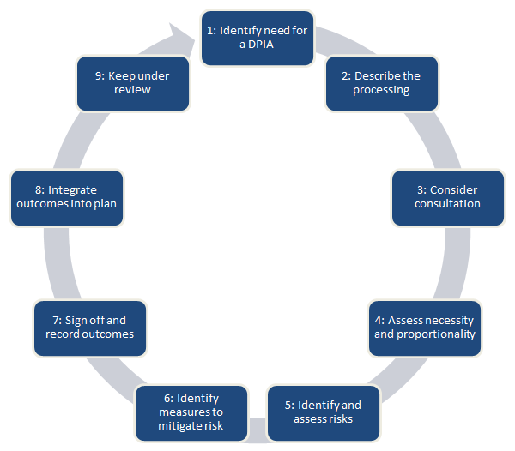
You must seek the advice of your data protection officer (if you have one). You should also consult with individuals and other stakeholders throughout this process.

The process is designed to be flexible and scalable. You can use or adapt the sample DPIA template or create your own. If you want to create your own, you may want to refer to the European guidelines which set out criteria for an acceptable DPIA.

Data Sharing
Liability in Lengthy Supply Chains
The GDPR provides that where there is more than one data controller or processor, and/or both are involved in the same processing and are responsible for any damage caused by that processing, each will be held liable for the entire damage to ensure that the data subject receives ‘effective compensation’. This raises two points:

1. that one organisation should be liable for the data breaches caused by another organisation; and
2. how the data subject should be compensated.

Recruitment supply chains are increasingly complex. Recruiters must pass personal data (including sensitive personal data) to:
- their clients which are prospective employers or users of temporary staff; and
- other entities either above or below them in the supply chain, whether vendors, managed service providers or payment intermediaries such as umbrella companies.

So, this means that in any recruitment supply chain there may be multiple data controllers and multiple data processors. An organisation might even be both at the same time. Contractual provisions between the different parts of the supply chain will be key.

Written Contract and Data Processor Obligations
The GDPR builds on an existing obligation that data controllers should have a written contract with their data processors. Data controllers should only choose data processors that will guarantee the implementation of ‘appropriate technical and organisational measures’ that adequately protect the rights of the data subject.

The written contract should include the following details about the processing:
- the subject matter;
- the duration of the data processing;
- the nature and purpose of the processing;
- the type of personal data;
- the categories of data subjects; and
- the obligations and rights of the data controller.

The contract should also include, as a minimum the following terms, requiring that the data processor:
- only processes personal data in accordance with the documented instructions from the data controller unless required to do so by law;
- commits to keeping processing completely confidential (including by any person that the processor allows to process personal data on its behalf e.g. employees, third parties);
- upon the request of the data controller, deletes or returns all of the personal data that has been processed to the controller and deletes existing copies (unless the processor is required by law to store the data);
- assists the data controller in meeting its GDPR obligations in relation to the security of data processing, the notification of personal data breaches and data protection impact assessments;
- implements organisational and technical measures that ensure a high level of security appropriate to the risk (including pseudonymisation, encryption of personal data, ongoing confidentiality, resilience of processing systems, a process for regularly evaluating the effectiveness of organisational measures);
- assesses the risks that are presented by data processing (this is also a responsibility of the data controller);
- assists the data controller to fulfil its obligation to respond to requests from the data subject to exercise their rights under the GDPR;
- makes available to the data controller all the necessary information to demonstrate compliance with the GDPR but also to contribute to any audits or inspections carried out by the data controller or another auditor on the controller’s behalf. In line with this, the processor must also inform the controller if it is instructed to carry out processing that may breach the GDPR; and
- In relation to sub-processors, the data processor has the obligation to not use another sub-processor without the prior written authorisation of the data controller. When seeking such authorisation, the data processor should inform the data controller of any changes concerning the addition or replacement of sub-processors.

Data processor obligations
Data processors will also have the additional obligations below:
- to comply with the contract that is set up between them and the data controller;
- to co-operate with the ICO;
- to appoint a data protection officer when the core activities of the processor involve the ‘regular and systematic’ monitoring of data subjects on a large scale;
- to appoint a representative within the European Union if the processing of data subjects within the EU is conducted by a processor or controller outside of the EU;
- to keep a written record (including in electronic form) of all categories of processing activities carried out on behalf of a controller

Contract between data processors and ‘sub-processors’
If the data processor engages another processor to process personal data (a ‘sub-processor’) on its behalf then it will have to also put in place a legal contract. This contract must impose the same obligations outlined above that the original data processor has on the sub-processor. In circumstances where the sub-processor fails to fulfil its own obligations, the original processor will ‘remain fully liable’ to the data controller for the performance of the sub-processor’s obligations.

Liability
A data processor will be held liable if:
- it does not comply with its obligations under the GDPR; or
- acts against or without the lawful instructions of the data controller.
For further advice, the ICO has produced guidance on the contracts and liabilities between data controllers and data processors.

Data Breach
Transferring Data Overseas
Under the DPA data controllers cannot transfer data to third countries (i.e. countries outside the EU) that do not have adequate levels of data protection. However organisations that work across multiple countries may rely on binding corporate rules or may engage with US based organisations that have Privacy Shield arrangements (formally Safe Harbour). The GDPR maintains the general prohibition on international transfers except where (a) the EU has given an ‘adequacy decision’ on a particular country, (b) binding corporate rules have been approved or (c) other appropriate safeguards are in place. This raises questions about cloud hosting arrangements which we will look at in a later edition of this guide.

Data Protection Breaches
The number of high profile and large scale cyber-attacks in 2017 serve as a reminder of the importance of investing in appropriate technologies and measures to protect data. A personal data breach is a breach that results in the destruction, alteration or unauthorised disclosure or access to personal data. There are three categories of a personal data breach:
1) Confidentiality breach – Where there is an unauthorised or accidental disclosure to personal data e.g. personal data is accessed by hackers.
2) Availability breach – Where there is an unauthorised or accidental loss of access to personal data or destruction of that personal data e.g. where the data controller can no longer restore access to a candidate’s personal data on a backup drive or where there has been a service attack or power cut that has resulted in personal data being temporarily or permanently unavailable.
3) An integrity breach – Where there is an unauthorised or accidental modification of personal data e.g. an authorised person changing details of a candidate’s personal data.
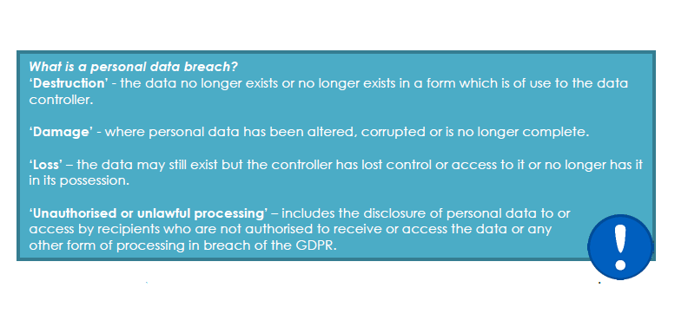
A breach may be identified as any one of or any combination of the above. There are various impacts on individuals of a breach including loss of control over their data, identity theft, fraud, financial loss, damage to reputation, loss of confidentiality and even discrimination.

Notification Obligation
The GDPR will oblige data controllers to notify the ICO, or any relevant supervisory authority, of all data breaches unless a breach is unlikely to result in a risk to the rights and freedoms of individuals (data breach reporting is not an obligation under the DPA). Data processors will be obliged to notify their data controllers of any personal data breaches as soon as they become aware of the personal data breach.

Reporting Timescales
When first being informed of a potential personal data breach, the data controller must, without undue delay and not later than 72 hours after having become ‘aware’ of it, notify the breach to the ICO or any relevant supervisory authority. In accordance with the WP29 guidance on data breach notification, the data controller may undertake a short period of investigation in order to establish whether or not a breach has in fact occurred. During that period of investigation, the controller may not be regarded as being aware of the breach. However, the initial investigation should begin as soon as possible and should establish, with a reasonable degree of certainty, whether a breach has taken place and the possible consequences for individuals - a more detailed investigation can then follow. In assessing whether a breach has taken place, consideration should be given to the likely risk to data subjects. The notification requirements above apply once the controller is aware that a breach has taken place.

In some situations, it will be very clear that a data breach has occurred whereas in other circumstances, it will take a proper investigation to establish what has occurred.

If a data processor becomes aware of a breach when it is processing data on behalf of a controller, it must notify that data controller as soon as they become aware of the breach. The GDPR does not specify the time period in which the processor must notify the controller, but WP29 suggests that it should notify the data controller of any breaches immediately.

The WP29 guidance suggests for notification in phases where the controller does not have all details of the breach within 72 hours of becoming aware of it. Part of the reason for the notification requirement is so that the data controller can get advice from the ICO about whether it also needs to notify individuals of the breach. If there are multiple breaches in a short time each one is a reportable incident. However, the controller may submit a ‘bundled’ notification provided they concern the same type of data breached in the same way over a short period of time. In certain circumstances, the controller may also delay notification beyond 72 hours whilst it is investigating the multiple breaches but should get advice from the ICO before it delays notification. Where a controller processes data in more than one Member State it must notify the lead supervisory authority.

Assessing The Risk of Personal Data Breaches
When a controller becomes aware of a personal data breach it must not only work to contain the breach but must also assess the risk that could result from it. When assessing risk the controller must consider the following:
the type of breach;
- the nature, sensitivity and volume of personal data;
- the ease of identification of individuals;
- the severity of the consequences for individuals
- any special characteristics of the individual;
- the number of affected individuals; and
- any special characteristics of the controller.

Data controllers should also ensure that they have the appropriate insurance in the event of a personal data breach or a cyber attack.

For more detailed guidance, please see the European Union Agency for Network and Information Security (ENISA) for recommendations on risk assessments.

For REC members who are concerned about cybersecurity, the National Cyber Security Council has produced guidance on cybersecurity.
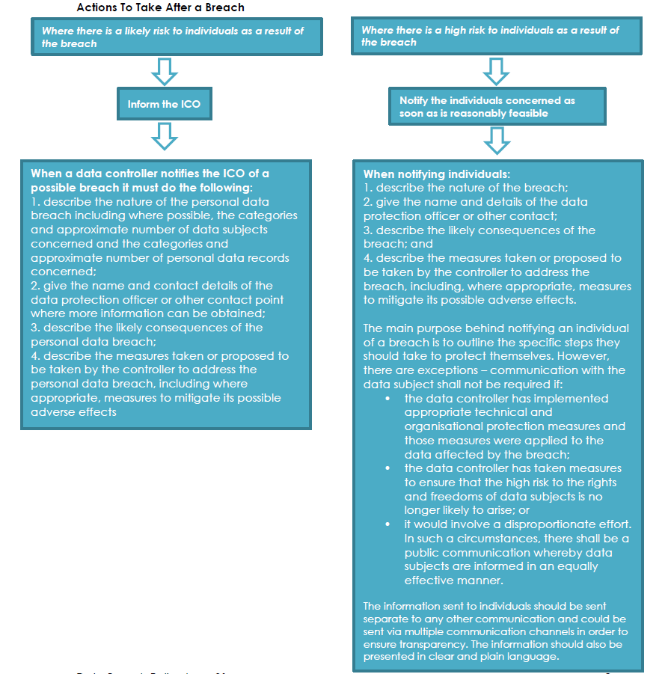

Keeping Records of Breaches
Even if a data controller does not have to notify the ICO and/or supervisory authority of a breach, it must still record the details of the breach including what caused the breach, what happened, and the personal data affected. It should also include the effects and consequences of the breach together with any remedial action taken by the controller. The WP29 also recommends that the controller explains its reasons for the actions it took in relation to the breach including the reasons for not notifying the supervisory authority. This will ensure compliance with the accountability principle under the GDPR.

For more detailed advice, please see the WP29 Guidance on personal data breach notification and the WP29 Guidelines on data protection impact assessments. Additionally, please see the ICO blog ‘Setting the record straight on data breach reporting’.

Personal Data Breaches By Employees
Candidate and client data are key assets belonging to a recruitment business. Recruitment organisations have always sought to protect themselves against theft of such data by using restrictive covenants in their staff employment contracts and appropriate misconduct provisions in various policies such a disciplinary, information security and data protection policies. However, they must also be aware that the misuse or theft of personal data, damaging as it is to their business, would also constitute a personal data breach and so would be reportable under GDPR. It would also be an offence under the new Data Protection Bill.

Subject Access Requests (Sar)
This right, commonly referred to as subject access, is created by section 7 of the Data Protection Act. It is most often used by individuals who want to see a copy of the information an organisation holds about them. However, the right of access goes further than this, and an individual who makes a written request and pays a fee is entitled to be:
- told whether any personal data is being processed;
- given a description of the personal data, the reasons it is being processed, and whether it will be given to any other organisations or people;
- given a copy of the information comprising the data; and given details of the source of the data (where this is available).
An individual can also request information about the reasoning behind any automated decisions, such as a computer-generated decision to grant or deny credit, or an assessment of performance at work (except where this information is a trade secret). Other rights relating to these types of decisions are dealt with in more detail in Automated decision taking.
In most cases you must respond to a subject access request promptly and in any event within 40 calendar days of receiving it. However, some types of personal data are exempt from the right of subject access and so cannot be obtained by making a subject access request. For more information, please see Exemptions.
The DPA allows an individual to make a subject access request (SAR) to the data controller. A SAR is a written request from an individual to the data controller to provide all of the information that the data controller holds on the data subject. At the time of writing organisations can charge a maximum fee of £10 per SAR. However, the GDPR will prohibit businesses from charging for SARs except where the SAR is excessive due to being ‘manifestly unfounded or excessive’, in particular due to it being repetitive. Even in these cases, the charge itself must be reasonable and must take into consideration the administrative costs involved. The draft Data Protection Bill allows the Secretary of State to set fees in these circumstances but at the time of writing we do not know what the fees may be.
The GDPR will also require organisations to respond to SARs within one month of receipt of the request rather than within 40 days as under the DPA. The period of one month can be extended by two further months taking into account the complexity and number of requests.

What is an individual entitled to?
Under the right of subject access, an individual is entitled only to their own personal data, and not to information relating to other people (unless they are acting on behalf of that person). Neither are they entitled to information simply because they may be interested in it. So, it is important to establish whether the information requested falls within the definition of personal data. In most cases, it will be obvious whether the information being requested is personal data, but we have produced separate guidance to help you decide in cases where it is unclear: Determining what is personal data (pdf). Please also see the key definitions.
Subject access provides a right to see the information contained in personal data, rather than a right to see the documents that include that information.
Various exemptions from the right of subject access apply in certain circumstances or to certain types of personal data; see Exemptions.

What is a valid subject access request?
For a subject access request to be valid, it should be made in writing. You should also note the following points when considering validity:

A request sent by email or fax is as valid as one sent in hard copy. Requests may also be validly made by means of social media; please refer to the Subject access code of practice (pdf) for guidance on this.
You do not need to respond to a request made verbally but, depending on the circumstances, it might be reasonable to do so (as long as you are satisfied about the person’s identity), and it is good practice to at least explain to the individual how to make a valid request, rather than ignoring them.
If a disabled person finds it impossible or unreasonably difficult to make a subject access request in writing, you may have to make a reasonable adjustment for them under the Equality Act 2010 (in Northern Ireland this falls under the Disability Discrimination Act 1995). This could include treating a verbal request for information as though it were a valid subject access request. You might also have to respond in a particular format which is accessible to the disabled person, such as Braille, large print, email or audio formats. If an individual thinks you have failed to make a reasonable adjustment, they may make a claim under the Equality Act (or Disability Discrimination Act 1995 in Northern Ireland). Information about making a claim is available from the Equality and Human Rights Commission or, as appropriate, from the Equality Commission for Northern Ireland.
If a request does not mention the Act specifically or even say that it is a subject access request, it is nevertheless valid and should be treated as such if it is clear that the individual is asking for their own personal data.
A request is valid even if the individual has not sent it directly to the person who normally deals with such requests – so it is important to ensure that you and your colleagues can recognise a subject access request and treat it appropriately.

Can I require individuals to use a specially designed form when making subject access requests?
No. Many organisations produce subject access request forms, and you may invite individuals to use such a form as long as you make it clear that this is not compulsory and you do not try to use this as a way of extending the 40-day time limit for responding. Standard forms can make it easier for you to recognise a subject access request and make it easier for the individual to include all the details you might need to locate the information they want.
However, any request in writing must be considered as a valid request, whatever the format.
Can I ask for more information before responding to a subject access request?
The Act allows you to confirm two things before you are obliged to respond to a request.
First, you can ask for enough information to judge whether the person making the request is the individual to whom the personal data relates. This is to avoid personal data about one individual being sent to another, accidentally or as a result of deception.
The key point is that you must be reasonable about what you ask for. You should not request lots more information if the identity of the person making the request is obvious to you. This is particularly the case, for example, when you have an ongoing relationship with the individual.
However, you should not assume that, on every occasion, the person making a request is who they say they are. In some cases, it is reasonable to ask the person making the request to verify their identity before sending them information.

What should I do if the data includes information about other people?
Responding to a subject access request may involve providing information that relates both to the individual making the request and to another individual. The Act says you do not have to comply with the request if to do so would mean disclosing information about another individual who can be identified from that information, except where:
- the other individual has consented to the disclosure; or
- it is reasonable in all the circumstances to comply with the request without that individual’s consent.
So, although you may sometimes be able to disclose information relating to a third party, you need to decide whether it is appropriate to do so in each case. This decision will involve balancing the data subject’s right of access against the other individual’s rights in respect of their own personal data. If the other person consents to you disclosing the information about them, then it would be unreasonable not to do so. However, if there is no such consent, you must decide whether to disclose the information anyway.
For the avoidance of doubt, you cannot refuse to provide subject access to personal data about an individual simply because you obtained that data from a third party. The rules about third party data apply only to personal data which includes both information about the individual who is the subject of the request and information about someone else.

If I use a data processor, does this mean they would have to deal with any subject access requests I receive?
Responsibility for complying with a subject access request lies with you as the data controller. The Act does not allow any extension to the 40-day time limit in cases where you have to rely on a data processor to provide the information that you need to respond.
If you use a data processor, then you need to make sure that you have contractual arrangements in place to guarantee that subject access requests are dealt with properly, irrespective of whether they are sent to you or to the data processor.
Read an explanation of the role of a data processor in who has right and obligations under the Data Protection Act?

Can I require an individual to make a subject access request?
It is a criminal offence, in certain circumstances and in relation to certain information, to require an individual to make a subject access request.



Signed Mark Trett – Operations Director
Date 1st July 2024
Review Date 1st July 2025

